Bullying prevention for schools

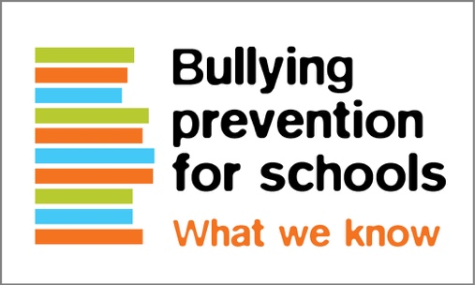
What we know
Bullying is an ongoing misuse of power in relationships through repeated verbal, physical and/or social behaviour that causes physical and/or psychological harm.
Read the full definition at http://bullyingnoway.gov.au/WhatIsBullying
Bullying:
- is a challenging social issue
- should be taken seriously
- is dynamic and complex
- involves students in varying roles in peer groups
- can be reduced and prevented
- can have lasting negative impacts
- requires multifaceted approaches
- needs individual and group level responses.

What works

Effective practices
Explicit teaching of school values and positive behaviour
Fostering a positive school climate
Integration of social-emotional learning
Proactive support and teaching of practical strategies
Whole school and multifaceted approaches
Involving students and families in bullying prevention and policy
Teaching bystander strategies
Being prepared with effective responses

Positive teacher-student relationships
Respect for students
Shared understating of bullying
Appreciation for students’ perspective about their social interactions
Consistent, calm and respectful responses
A focus on lasting, positive solutions

Positive family relationships
Parenting that is calm and firm
Proactive discussions at home about bullying
Learning about effective responses
A focus on lasting, positive outcomes
Collaboration with the school
Sources can be found at:
https://bullyingnoway.gov.au/understanding-bullying/bullying-research

Facts and figures
Approximately one in four Year 4 to Year 9 Australian students (27%) reported being bullied every few weeks or more often.
Students may not report bullying to the school because they fear not being believed or making things worse.
Approximately one in five school students reported experiencing online bullying in any one year.
In 85% of bullying interactions, peers are present as onlookers, and play a central role in the bullying process.
Hurtful teasing was the most common bullying behaviours reported, followed by having hurtful lies told about them.
32% of Year 5s and 29% of Year 8s reported frequent school bullying.
Students often tell parents about bullying rather than anyone else.
Enhancing social status with peers is the most commonly reported motivator for bullying.
83% of students who bully others online also bully others in person.
84% of students who were bullied online were also bullied in person.
Students 10 to 15 years of age are the most likely to be involved in online bullying.
72% of schools reported managing at least one incident of online bullying in the previous year.

A shared definition and understanding is critical to finding positive and lasting solutions for everyone involved.

The national definition of bullying for Australian schools is the starting point for bullying prevention.

Bullying is an ongoing and deliberate misuse of power in relationships through repeated verbal, physical and/or social behaviour that intends to cause physical, social and/or psychological harm. It can involve an individual or a group misusing their power, or perceived power, over one or more persons who feel unable to stop it from happening.
Bullying can happen in person or online, via various digital platforms and devices and it can be obvious (overt) or hidden (covert). Bullying behaviour is repeated, or has the potential to be repeated, over time (for example, through sharing of digital records).
Bullying of any form or for any reason can have immediate, medium and long-term effects on those involved, including bystanders. Single incidents and conflict or fights between equals, whether in person or online, are not defined as bullying.

Read more about effective ways to prevent bullying at Bullying. No Way! www.bullyingnoway.gov.au

